Logic Gates #3 - CircuitPractice

Remember the Rules!

AND Gate - both A & B must be on for the output to be on

OR gate - if at least A or B is on, the output is on

NOT gate - reverses the incoming wire

Circuit 1

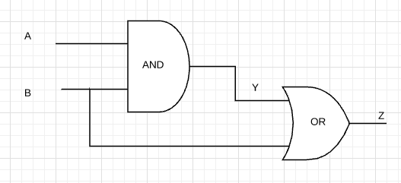

Truth Table for Circuit 1:

| A | B | Y | Z |
| --- | --- | --- | --- |
| 0 | 0 |  |  |
| 0 | 1 |  |  |
| 1 | 0 |  |  |
| 1 | 1 |  |  |

Circuit 2

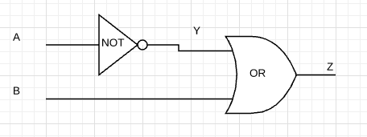

Truth Table for Circuit 2:

| A | B | Y | Z |
| --- | --- | --- | --- |
| 0 | 0 |  |  |
| 0 | 1 |  |  |
| 1 | 0 |  |  |
| 1 | 1 |  |  |

Circuit 3:

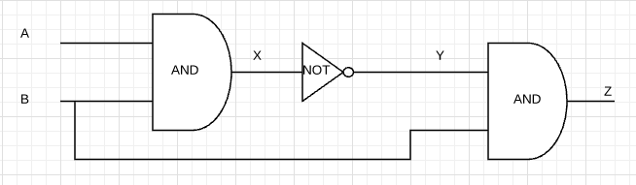

Truth Table for Circuit 3:

| A | B | X | Y | Z |
| --- | --- | --- | --- | --- |
| 0 | 0 |  |  |  |
| 0 | 1 |  |  |  |
| 1 | 0 |  |  |  |
| 1 | 1 |  |  |  |